

Group

PROJECT

**(2022-23)**

**“**Smart Wearable AI IOT for Appliance Control**”**

Project Report

**Department of Computer Engineering & Applications**

**Institute of Engineering & Technology**

**Submitted By -**

Biprajit Debnath (191500221)

Devansh Jain (191500254)

Anindya Trivedi(191500116)

Akash Nigam(191500074)

Akarsh Agarwal(191500069)

**Github Repo Link :-**

<https://github.com/biprajit1999/SmartWearable.git>

## Declaration

I/we hereby declare that the work which is being presented in the Bachelor of technology. Project **“Smart Wearable AI-IOT”**, in partial fulfillment of the requirements of the assignment given by the Department of Computer of Computer Engineering & Applications, is an authentic record of my/our own work carried out.

The contents of this project report, in full or in parts, have not been submitted to any other Institute or University for the award of any degree.

## Certificate

###### This is to certify that the project entitled “Smart Wearable AI-IOT”, carried out in Major Project in the Centre for Skill & Entrepreneurship Development, is a bonafide work by Group 73 and is submitted in partial fulfillment of the requirements of the assignment given by Department of Computer Engineering & Applications.

**ACKNOWLEDGEMENT**

Accordingly, the present invention provides a Low-Cost Wearable Health Monitoring Device comprising plurality of sensors to measure the vital information of a old or disabled person; a module consisting pre-programmed controller which store the normal vital parameter to be monitored, during old age and based on comparison generating an alert signal which is transmitted through a transmitter to ambulance, doctor and family member; a communication device adapted for continuous establishment of network with the data storing means where the vital information gets stored; and output means from where the family member and doctor can access the information. The system has an advantage of creating a proper database of the old/disabled person and is cost-efficient and reliable.

###### Thanking You

**Sign:** *Biprajitdebnath*

**Name of Candidate:** Biprajit Debnath

**Sign:** *Devanshjain*

**Name of Candidate:** Devansh jain

**Sign:** *Anindyatrivedi*

**Name of Candidate:** Anindya Trivedi

**Sign:** *Akashnigam*

**Name of Candidate:** Akash Nigam

**Sign:** *Akarshagrawal*

**Name of Candidate:**  Akarsh Agarwal

**ABSTRACT**

The present invention provides a Low-Cost Wearable Health Monitoring Device comprising plurality of sensors to measure the vital information of an old or disabled person; a module consisting pre-programmed controller which store the normal vital parameter to be monitored, during old age and based on comparison generating an alert signal which is transmitted through a transmitter to ambulance, doctor and family member; a communication device adapted for continuous establishment of network with the data storing means where the vital information gets stored; and output means from where the family member and doctor can access the information. The system has an advantage of creating a proper database of the old/disabled person and is cost-efficient and reliable.

**Table of Contents**

| **Declaration**  **Certificate**  **Acknowledgement**  **Abstract** |  | **II**  **III**  **IV**  **V** |
| --- | --- | --- |
| **1. Introduction** |  | **1** |
|  |  |  |
| 1.1: Motivation  1.2: Overview  1.3: Objective |  | 1  1  1 |
|  |  |  |
| **2. Software Requirement Analysis** |  | **2** |
|  |  |  |
| 2.1: Define Problem  2.2: Define Modules  2.3: Software Requirement  2.4: External Interface Requirement  2.5: Functional Requirement |  | 2  2  3  4  4 |
|  |  |  |
| **3. Software Design** |  | **6** |
|  |  |  |
| 3.1: Data Flow Diagram  3.2: UML Diagram  3.3: System Overview Diagram  3.3: Database Design 9  3.4: Circuit Diagram 10  3.5: Appliance Diagram 11 |  | 6  7  8 |
|  |  |  |
| **4. Software & Hardware Testing** |  | **12** |
|  |  |  |
| 4.1: Testing of Hardware Components  4.2: Testing of main session |  | 13  14 |
|  |  |  |
| **5. Implementation and user Interface** |  | **15** |
|  |  |  |
| 5.1: Implementation  5.2: User Interface/ |  | 16  17 |
|  |  |  |
| **References/Bibliography**  **6.Appendices** |  | **18** |
|  |  |  |

CHAPTER-1

INTRODUCTION

**1. CONTEXT**

This project will solve all the major problems that are faced by an aged person and this will be very beneficial for both the person and the doctor, as the person doesn’t have to go for routine checkup but whenever there is a requirement our project will notify both the person and the doctor.

As this device is going to be reusable i.e. this device can be used multiple times. Hence, this wearable health monitoring device for elderly and disabled can be easily affordable by anyone.

### 2. MOTIVATION

In the past few years, we have realized that the Elderly or a disabled faces a lot of problems. The motivation behind this project is to provide an elderly or a disabled person a complete all-in-one package to monitor the health of the person and provide insights about health to both guardian and the doctor.

In the century we are living in, the world is progressing at a really great pace, a lot of technologies come up every single day. To keep up with technology is also important to survive in this world of digitalization and learning. Along with this we need to have a place to keep the resources for areas of our interest so we thought of developing a wearable device which could provide us a complete overview of the person’s health.

Adding to its features, the kit will come with a dedicated application and a fall alert system.

### 3. OBJECTIVE

Smart Wearable AI-IOT’s objective is to provide a complete health monitoring system of a person and help in appliance control available at an affordable cost. Users can monitor their health and also control some common appliances like Microwave, Air Conditioner, Toaster, etc.

The goal of the kit is to monitor a person’s health and help the person to control home appliances and also alert the doctor and guardian of the person about any abnormality.

**4. Existing System**

In the present scenario, many people suffer from some kind of disability or are too old. With the help of this kit we will be able to keep a complete supervision of the patient.

As soon as the user wears the kit, the sensors will start collecting data and store it in the database.On the basis of certain constraints the kit will generate the reports for the guardian.

The source of our project (including all the project work, documentations and presentations) will be available at the following link.

<https://github.com/biprajit1999/SmartWearable.git>

### 

### SOURCES

Wearables are electronic technology or devices incorporated into items that can be comfortably worn on a body. These wearable devices are used for tracking information on a real time basis. They have motion sensors that take the real time data of your day to day activity and sync them with mobile devices or laptop computers.

The source of our project (including all the project work, documentations and presentations) will be available at the following link.

<https://github.com/biprajit1999/SmartWearable.git>

**CHAPTER -2**

**SOFTWARE REQUIREMENT ANALYSIS**

**2.1 Problem Statement**

To provide a device where users can monitor their health in the real time and generate alerts in case of abnormality to guardians and doctors.

**2.2 Modules**

The project is based on several modules:

**2.2.1 Product perspective**

1. The IOT device is fixed on the safety jacket .This smart jacket is fixed with 9 useful sensors for monitoring the health of the aged person.
2. These sensors are connected across the network through Wi-Fi under IEEE standard 802.11 b/g/n makes them more relevant and valuable than ever before.
3. By turning sensor information into actions, real time data of personal health can be monitored and controlled remotely from anywhere.
4. The information can be monitored through an ISO android app and personal computers remotely.

**2.2.2 Product Functions**

The Kit will allow users with specific roles (Administrator- Hold the complete health details, User (Patient).A summary of the major functions that the kit will perform:

a. Provide a facility to users to control appliances and to help guardians to keep an eye on the patient’s health.

b. Users can also keep an eye on their health data collected by sensors.

c. Report any case of abnormality to both guardian and doctor.

***2.2.2.1Administrators***

* *Admin should be able to maintain the data.*
* *Update information about heart rate, temperature, etc.*
* *Can login into the mobile application and observe their health status.*

***2.2.2.2 User***

* *Can track their health in real time*
* *Can generate emergency alerts in case of any health problems or serious cases.*
* *Can login into the website and observe their health status.*

**2.2.3 User Characteristics**

No Prior Knowledge is Required but some key tips**-**

**a.** **Educational level:** Users should be comfortable with the English language.

**b**. **Experience:** Users should have prior information regarding using a mobile application.

**c**. **Skills:** Users should have basic knowledge and should be comfortable using general purpose applications on computers.

**2.2.4 General Constraints**

* The time allotted for this project will be limited to the end of this semester.
* It can be happened that some information could not be correct because it is providing by other sensors.
* Programming is done by Arduino IDE, Thingworx, MIT App Inventor , Firebase, HTML,JAVASCRIPT.

### 2.3 HARDWARE AND SOFTWARE REQUIREMENTS

**Hardware Requirement**

* + - Processor :intel i5
    - Operating System :Any Operating System
    - RAM : 8 GB (or higher)
    - Hard disk : 256GB

**Software Requirement**

* + - Software used: Arduino IDE
    - Language used : Embedded C, Python.
    - Database: Firebase, Thingworx.
    - User Interface Design : Android Application

CHAPTER- 3

**SOFTWARE DESIGN**

### USE-CASE DIAGRAM:

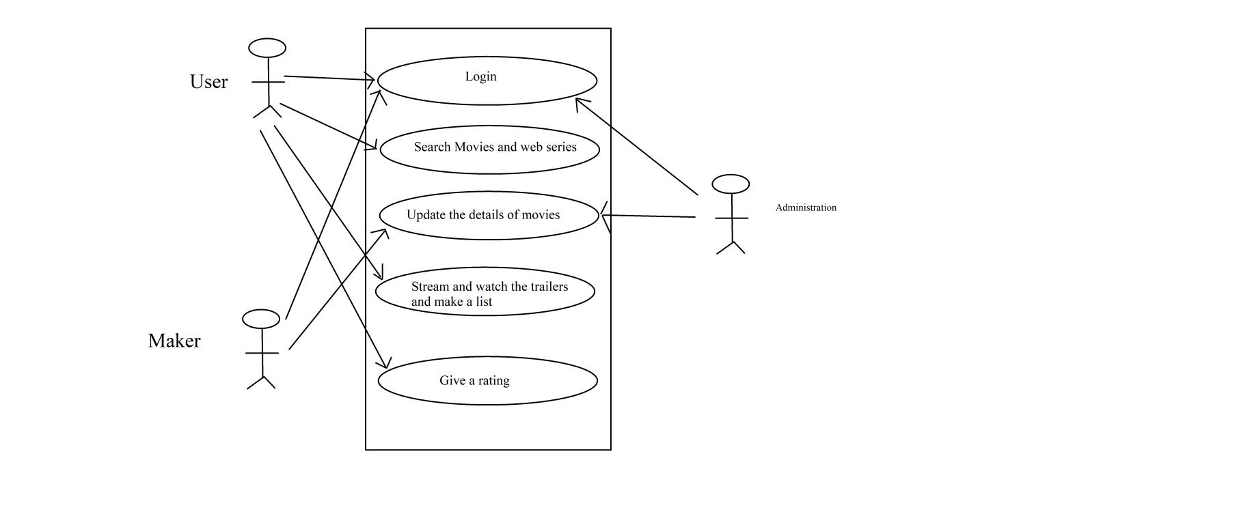

**Figure-1: Use–Case Diagram**

So the above diagram represents the point of view of the new user, the registered user, and the developer and the arrows to each module show the interactivity of the person.

The New user will first be required to create up a new account so will interact with the “sign-up module” and fill up all the details that will be stored in the database. The next user will land into the dashboard where there will be “search bar” where the user can enter the book he desires to read or any related keyword to the book. The list of movie will appear on the screen and the new user will interact with “select the movie” module. Then the user can interact with the “Description of the Book” module to read more about the movie.

For the registered user, the user will be having the credentials to login and will interact with the “login module” and then the user will enter into the dashboard where there will be “search bar” where the user can enter the movie he desires to read or any related keyword to the movie. The list of movie will appear on the screen and the new user will interact with “select the movie ” module. Then the user can interact with the “Description of the movie ” module to read more about the movie.

For the developer he can connect with each and every module mentioned in the use case diagram. Apart from the modules mentioned in use case diagram there are modules like profile, sign out, FAQ and about us section that every registered user can access.

* 1. **DATA FLOW DIAGRAM**

Equipped with hardware, such as MPU6050 and heart rate sensor, wearables enable measuring physical activities and heart rate. However, the accuracy of these heart rate measurements is still unclear and the coupling with activity recognition is often missing in health apps. This study evaluates heart rate monitoring with four different device types: a specialized sports device with chest strap, a fitness tracker, a smart watch, and a smartphone using photoplethysmography. In a state of rest, similar measurement results are obtained with the four devices. During physical activities, the fitness tracker, smart watch, and smartphone measure sudden variations in heart rate with a delay, due to movements of the wrist. Moreover, this study showed that physical activities, such as squats and dumbbell curl, can be recognized with fitness trackers. By combining heart rate monitoring and activity recognition, personal suggestions for physical activities are generated using a tag-based recommender and rule-based filter.

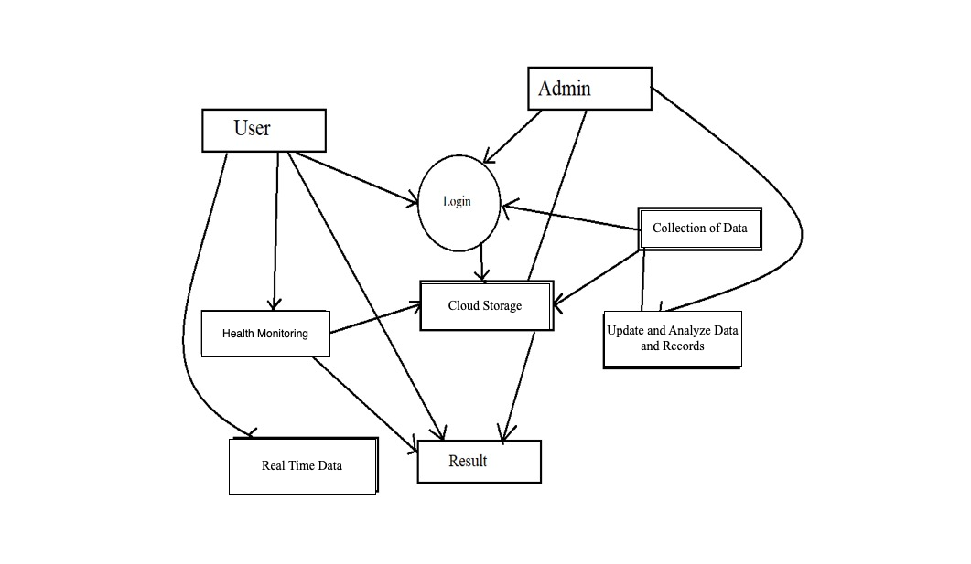

**Figure 2: Data Flow Diagram**

**3. System Overview**

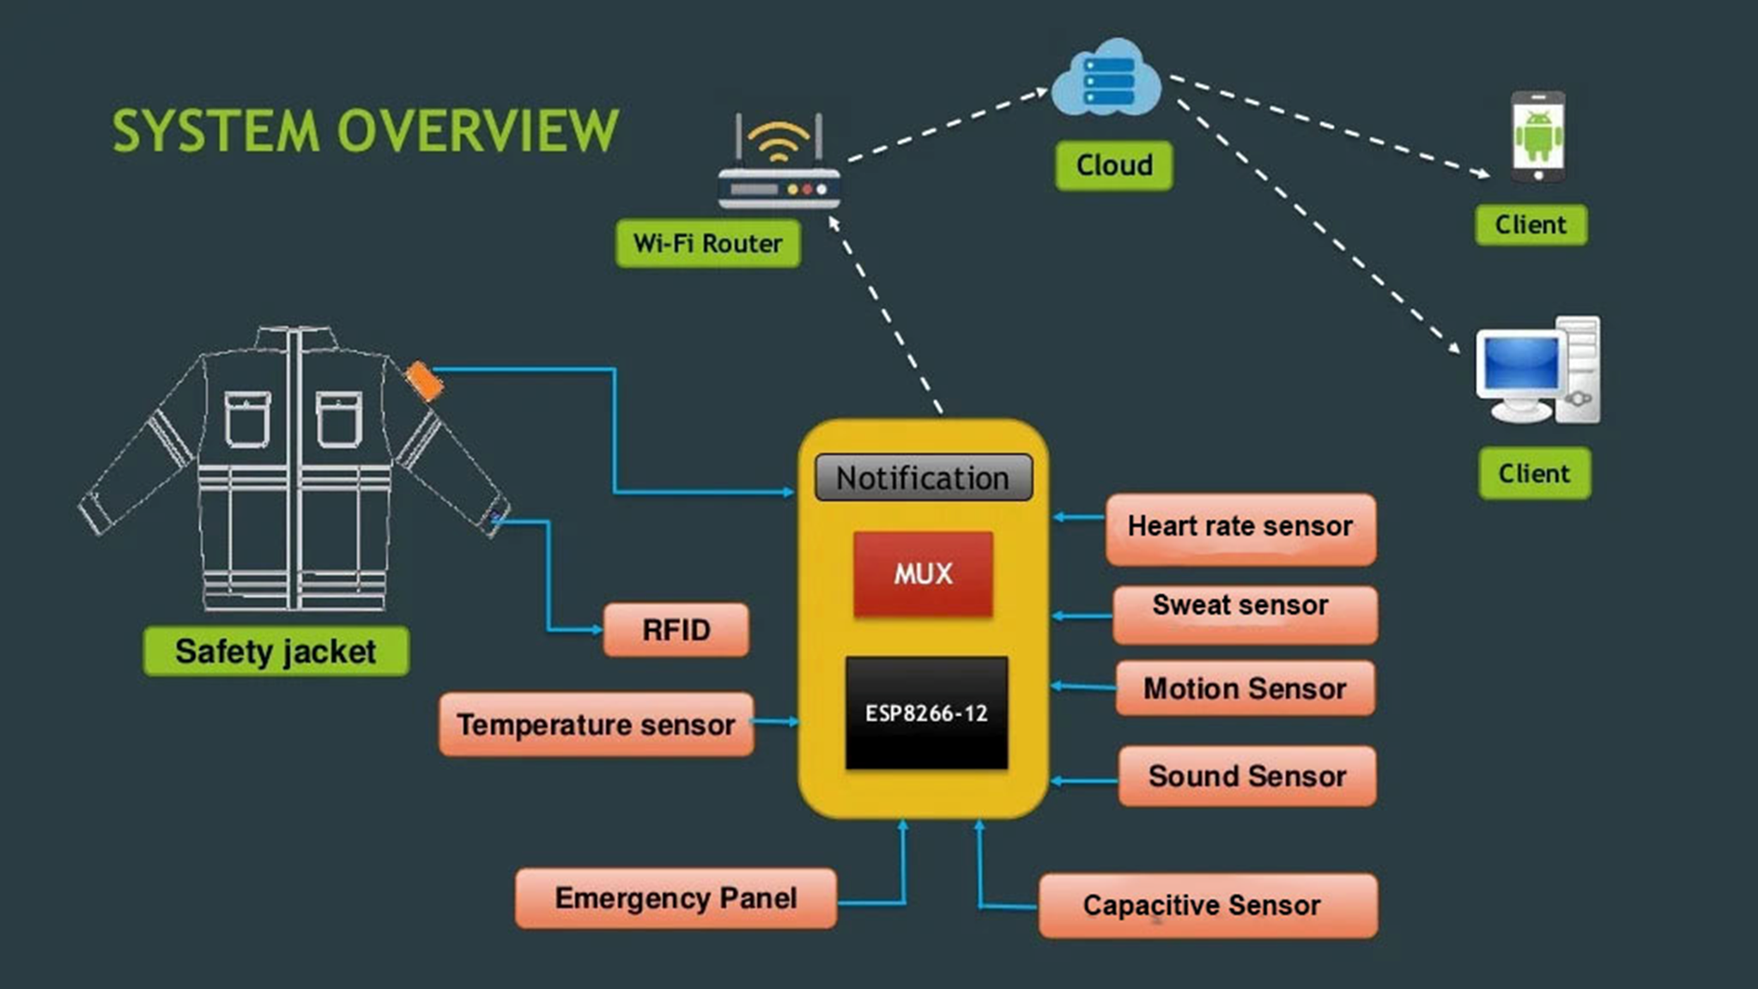

**Figure 3: System Overview**

### 4. SEQUENCE DIAGRAM

### 

**Figure 4: Sequence Diagram**

**5. Circuit Diagram**

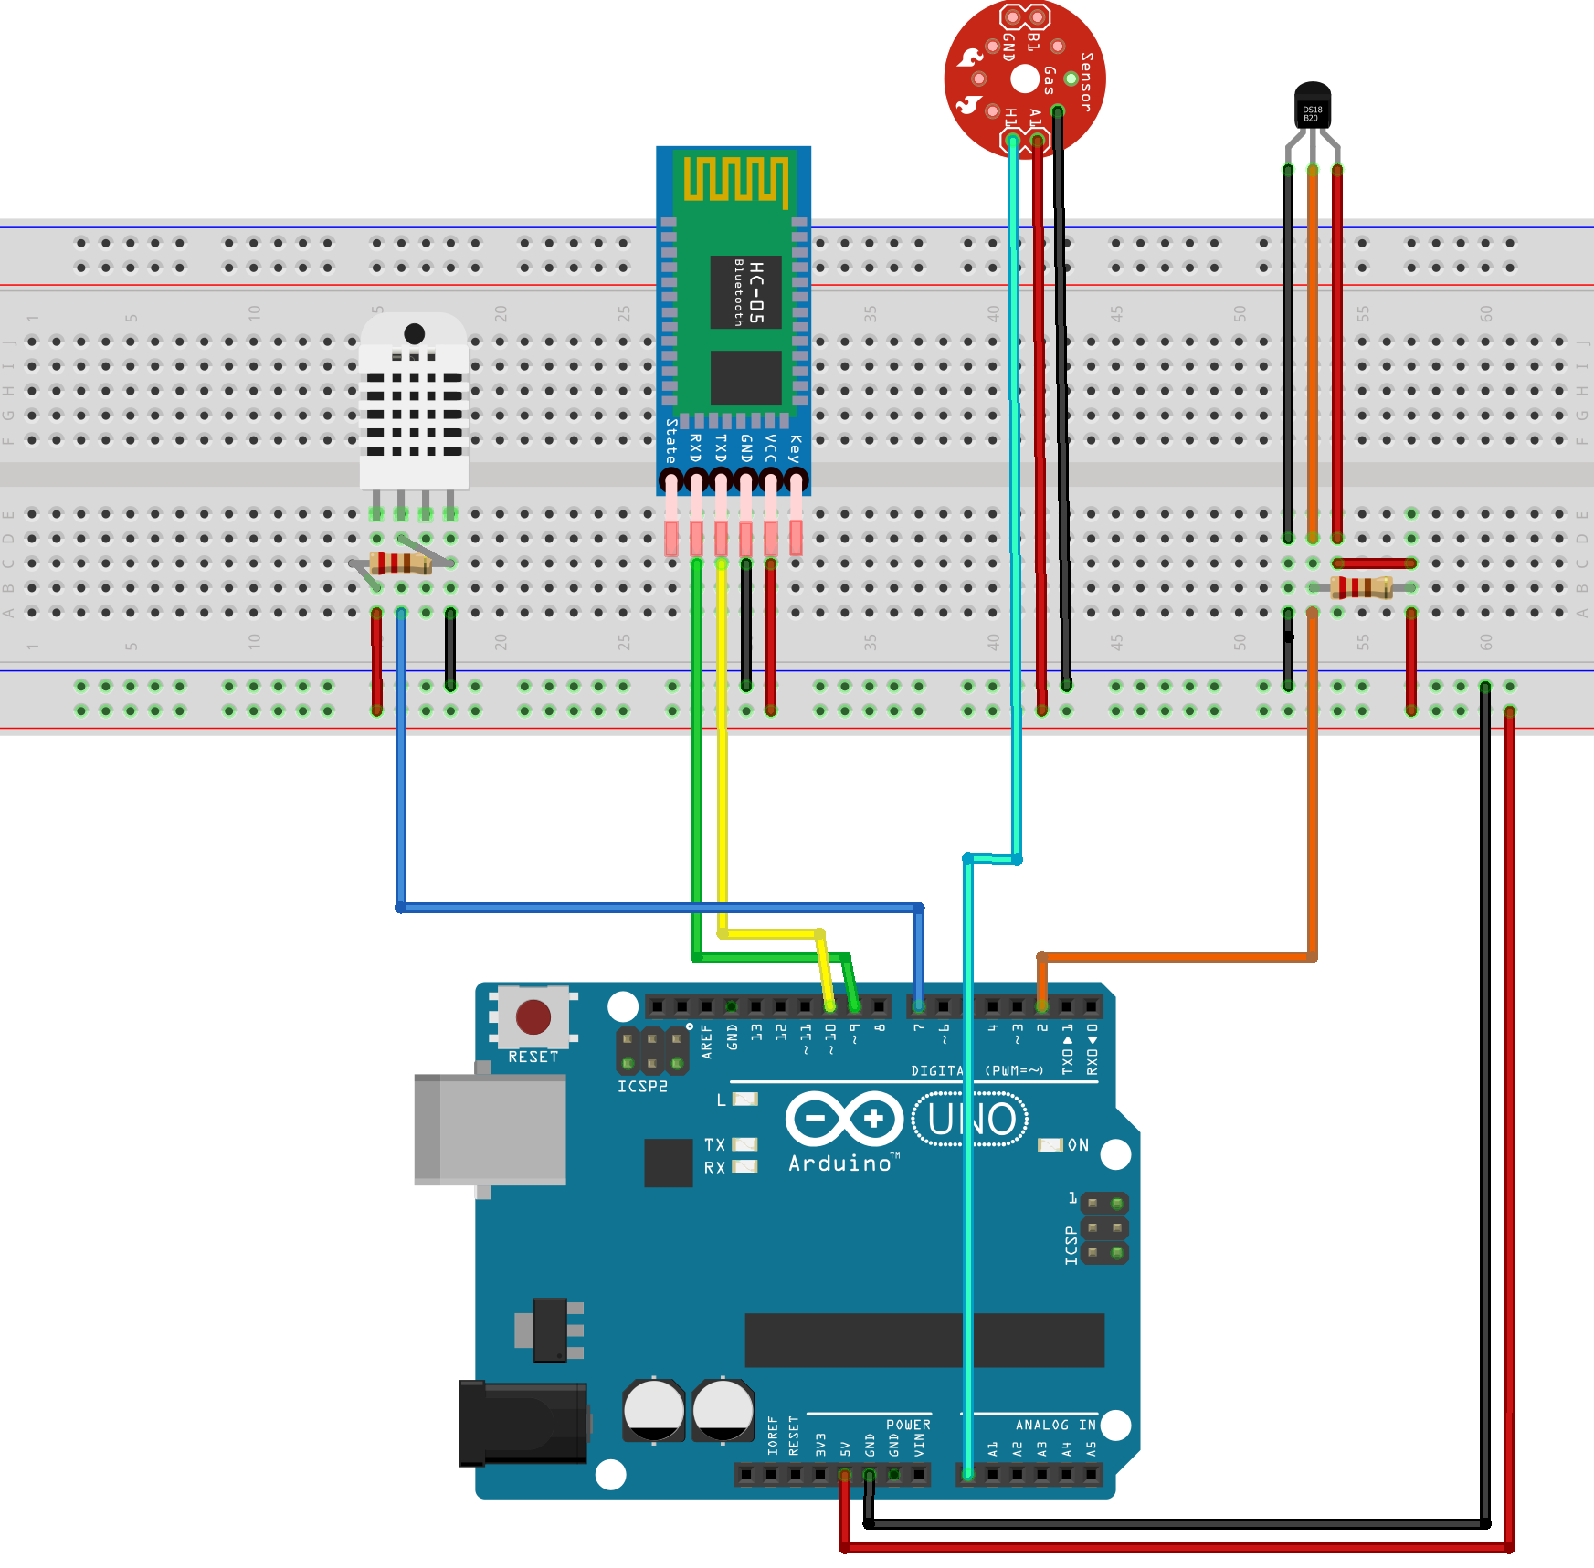

**Fig 5 : Circuit Diagram**

**6. Appliance Diagram**

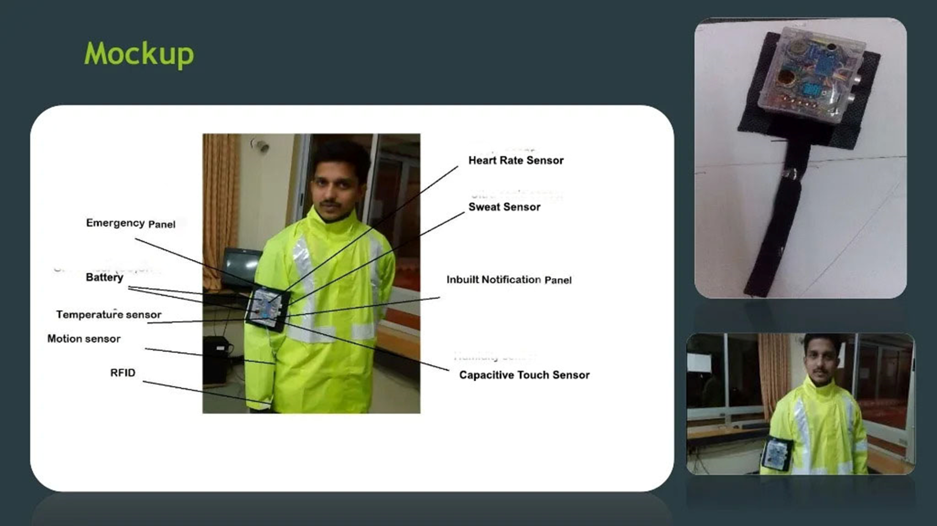

**Figure 6: Proposed Appliance Diagram**

**. Software Testing**

Software testing is an investigation conducted to provide stakeholders with information about the quality of the software product or service under testing. Software testing is a process of executing a program or application with intent of finding the software bugs. It can also be stated as the process of validating and verifying that a software program or application.

1. **User Testing**

User testing is the process through which the interface and functions of a website, app, product, or service are tested by real users who perform specific tasks in realistic conditions. The purpose of this process is to evaluate the usability of that website or app and to decide whether the product is ready to be launched for real users.

This website was tested by our team mates and friends who are using different mobile phones also tested on different emulator to check its performance and it seems to be working fine and users of this app are satisfied with the facilities and performance of the website and like the way how the website is worked.

* 1. **Performance Testing**

In this type of testing we have checked the performances of our website under some peculiar conditions. Those conditions include:

* + - Low memory in the device.
    - The battery in extremely at a low level.
    - Poor/Bad network reception.

Performance is basically tested from 2 ends, application end, and the application server end. Our app is also performing well in this phase of testing as well. And we are getting positive feedback from user of our website.

* 1. **Compability Testing**

This service was tested and used on different devices like chrome ,tablet. The website worked fine and is stable. The application worked fine in portrait mode and there isn't any problem with compatibility.

On all types of testing (that we have performed above) our performing well on our website i.e. SmartWearable

**CHAPTER -7**

**CONCLUSION**

The project has proposed the idea of smart wearable that can support keeping a health track for a lot of aged people at a very cheap and affordable price. The smart wearable device contains a connection between wireless communication, several sensors, monitoring and tracking. In this project a smart and efficient approach for Smart Wearable AI IOT for Appliance Control was proposed and implemented.

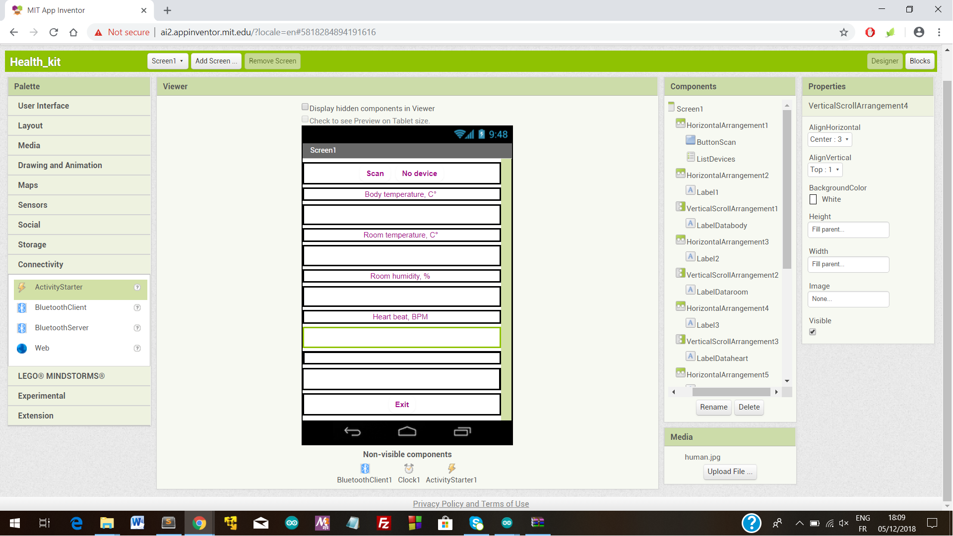

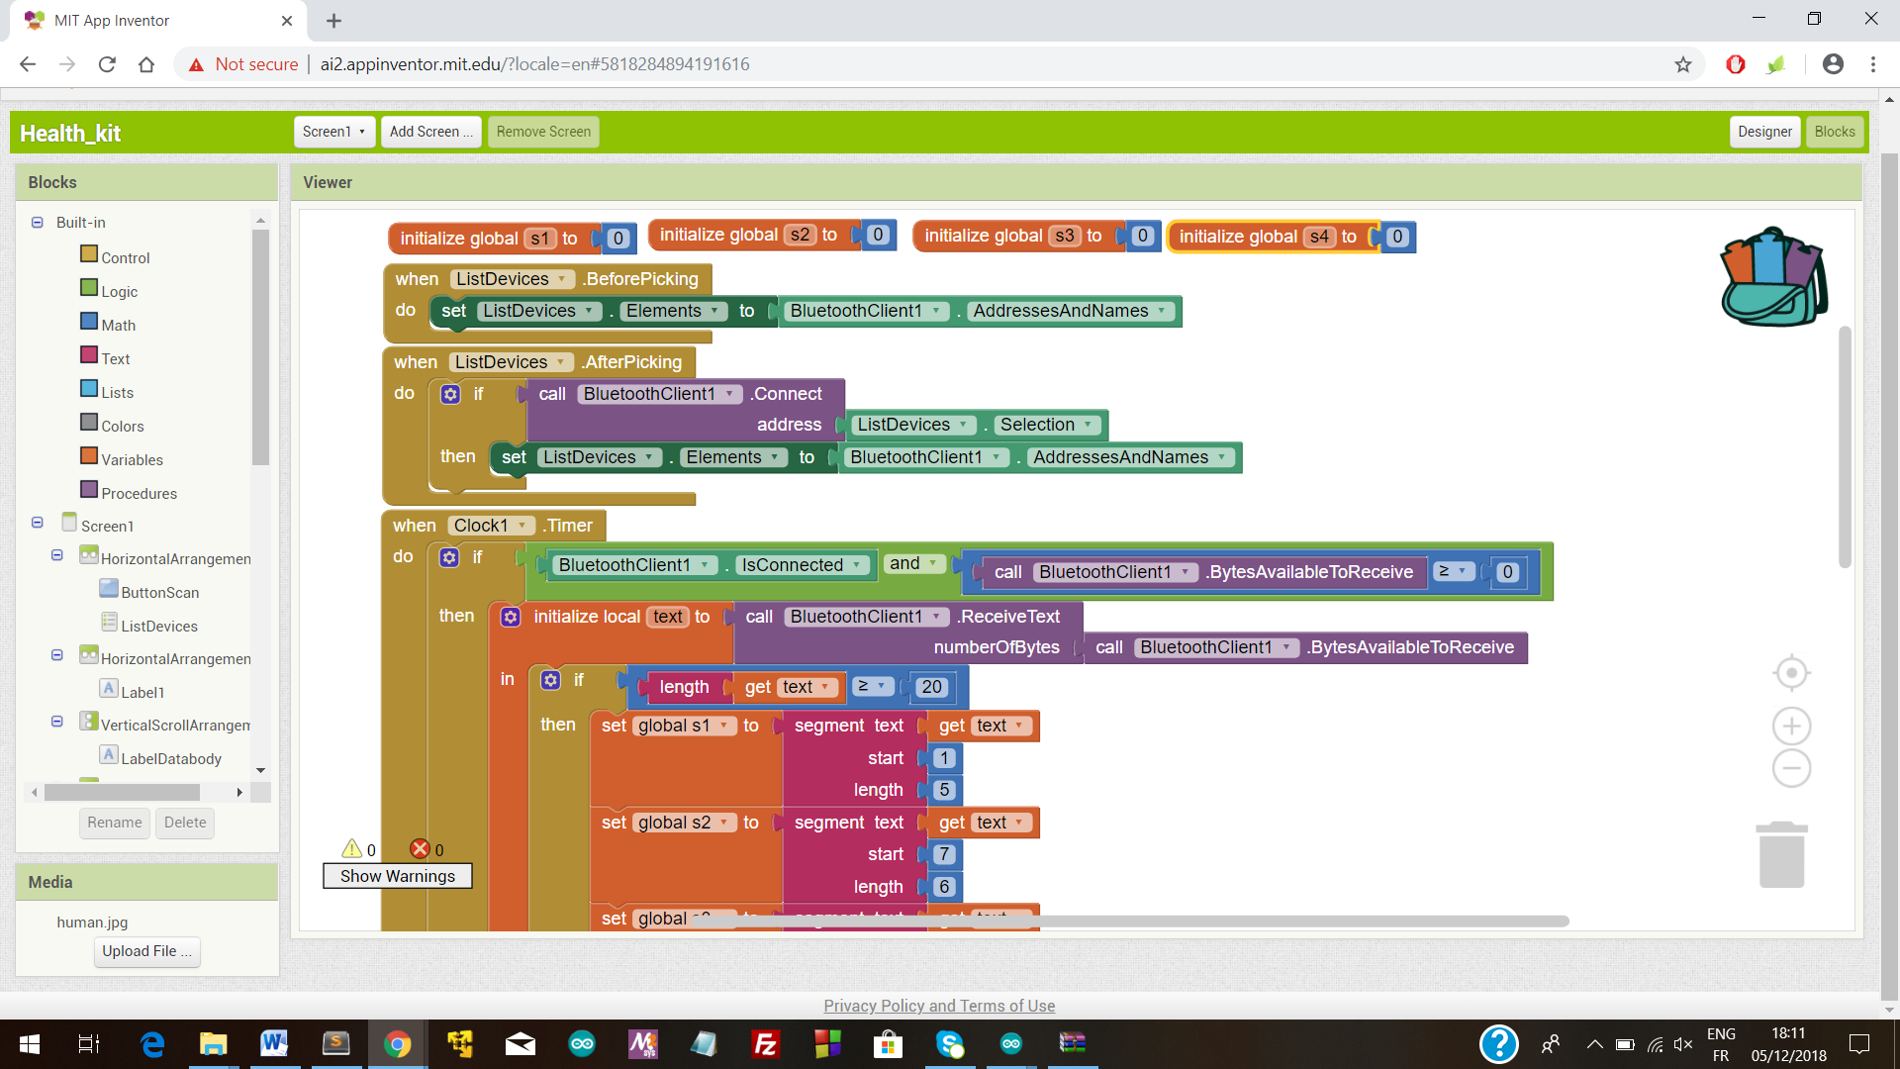

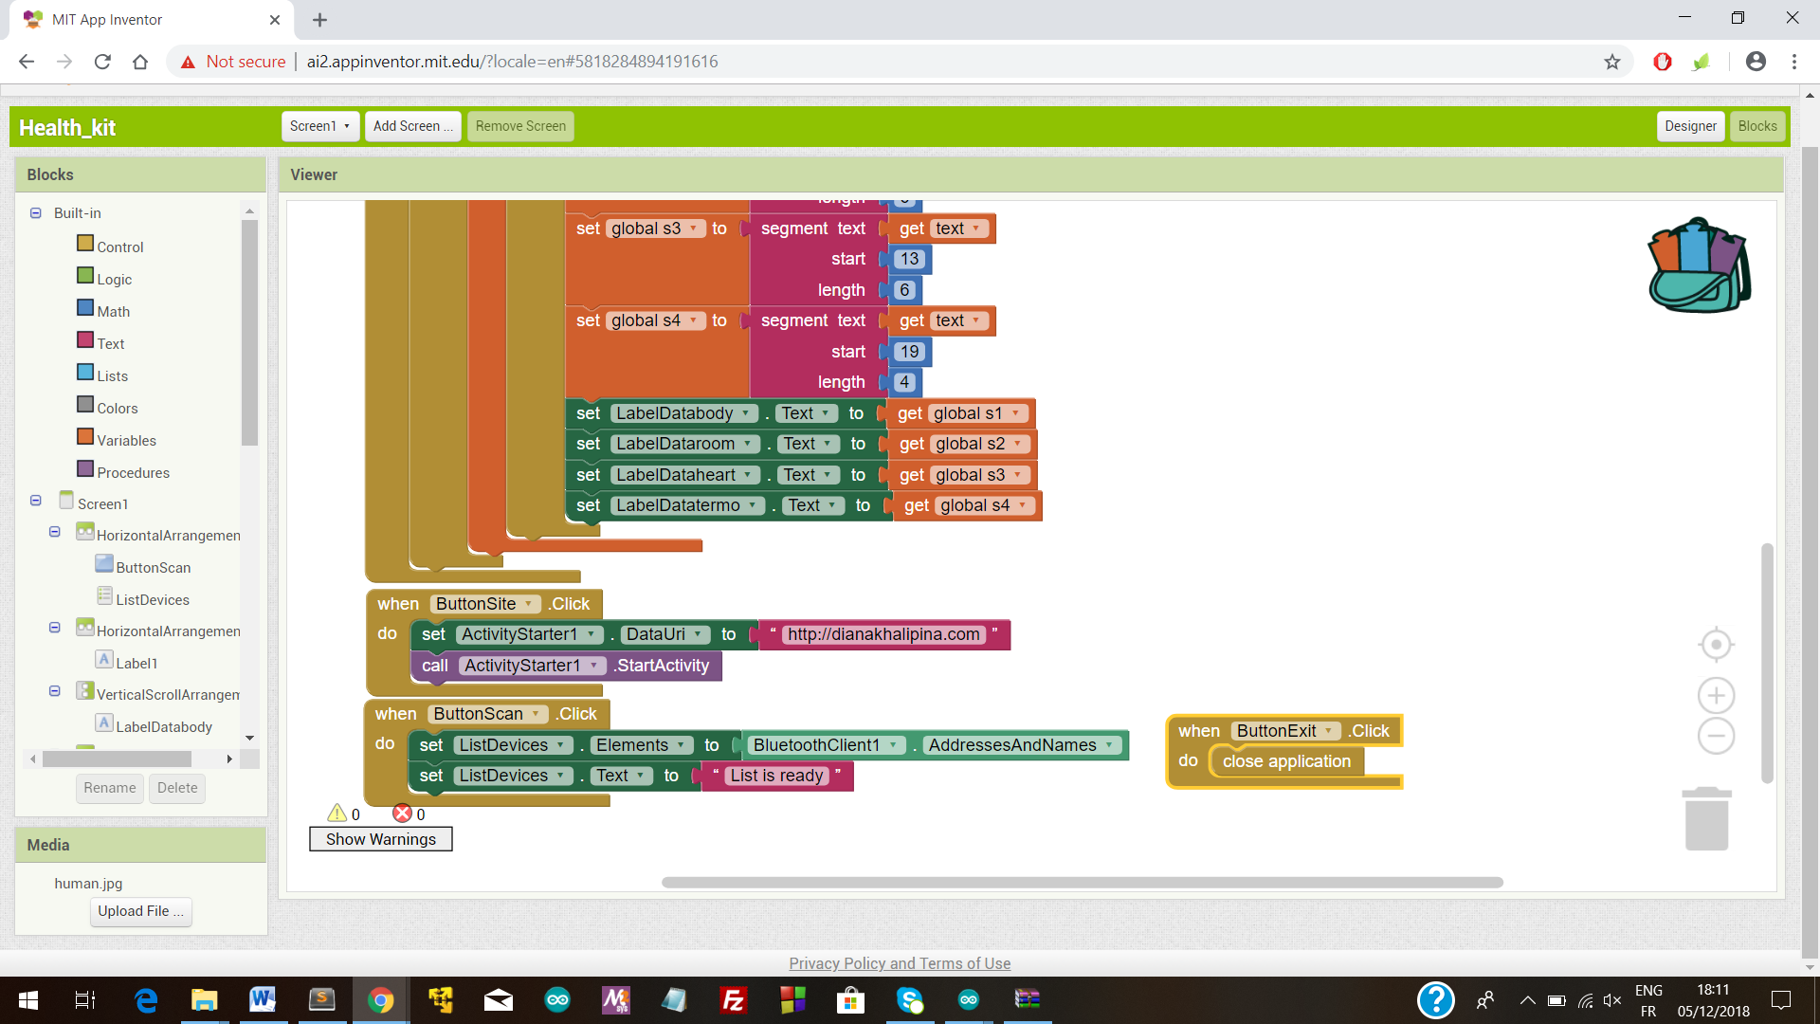

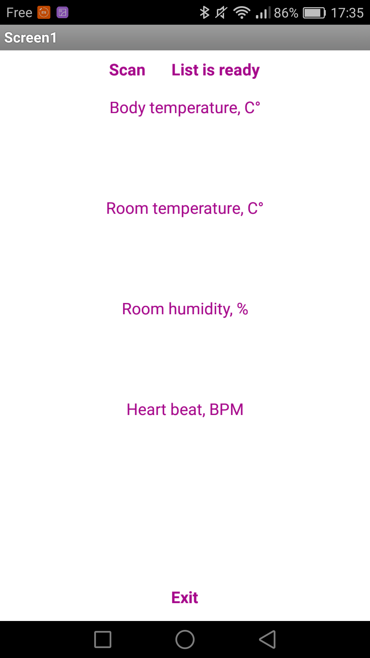

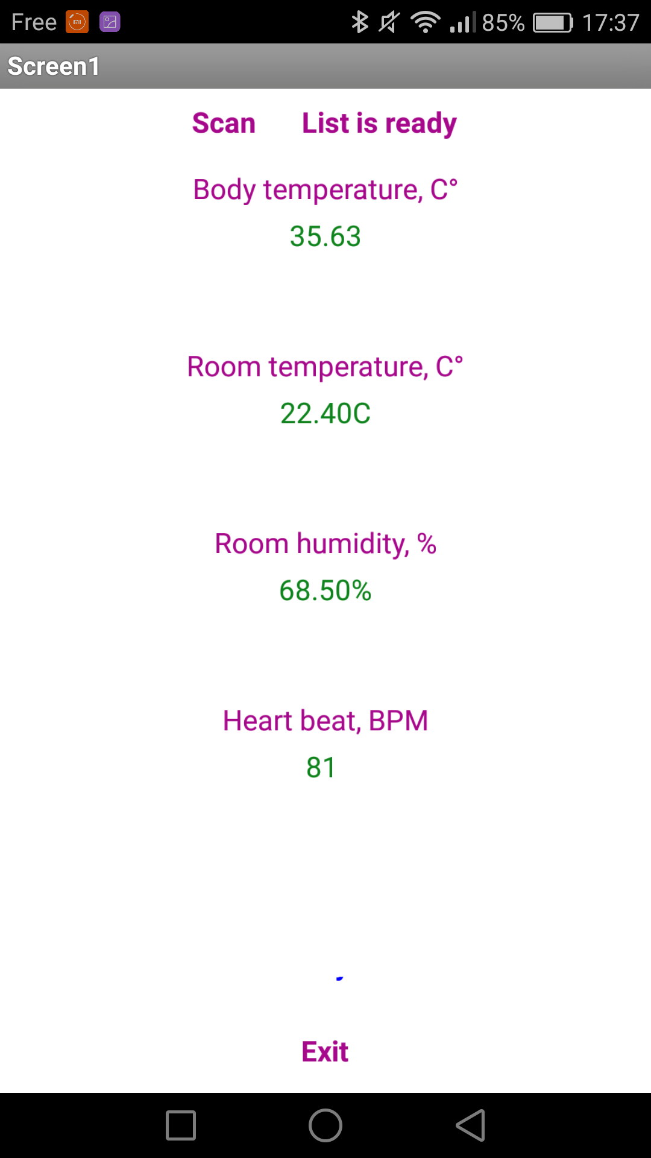

**Reference**

Reference - 1 :-

A Smart Helmet for Air Quality and Hazardous Event Detection for the

Mining Industry

C. J. Behr, A. Kumar, G. P. Hancke

2016 IEEE International Conference on Industrial Technology (ICIT)

Year: 2016

Pages: 2026 - 2031, DOl: 10.1109/ICIT.2016.7475079

Reference - 2 :-

Zig-Bee Based Intelligent Helmet For Coal Miners

Arun Katara, Anand Dandale, Abhilesh Chore, Anura Bhandarwar

2015 Fifth International Conference on Communication Systems and Network Technologies

Year: 2015

Pages: 314 - 317, DOI:10.1109/CSNT.2015.142

IEEE Conference Publications